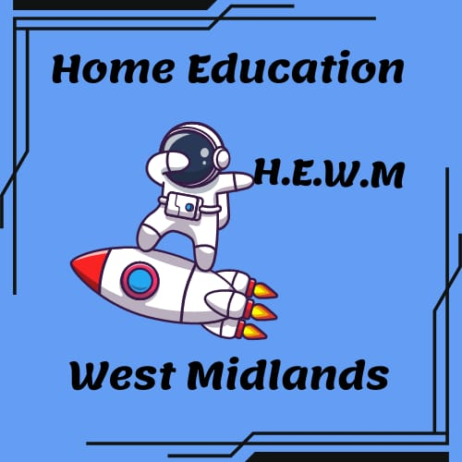

**Home Education Report Template**

**Child Information**

* **Full Name**: [Child's Full Name]
* **Date of Birth**: [Date of Birth]

**Our Educational Approach**

Briefly describe your educational philosophy (e.g., desired outcomes, learning style - structured/semi-structured/child-led).

**About [Child's Name]**

Briefly describe your child's personality, interests, learning style, and aspirations.

**Education**

**Learning Areas** (Adapt and add sections as needed)

* **[Learning Area Name]**
  + **Activities:** List activities your child engages in to learn this subject.
    - Include everyday activities, games, projects, educational resources (websites, apps, books).
  + **Resources:** List specific resources used (websites, books, etc.)

**Examples:**

**Maths/Numeracy**

* **Activities:** Shopping, cooking, baking, games and puzzles, Lego, Minecraft, educational websites and apps
* **Resources:** Khan Academy (website), Prodigy (app), Math Playground (website)

**Literacy**

* **Activities:** Reading aloud, independent reading, writing stories/poems/reports, discussing books and characters, educational websites and apps
* **Resources:** Reading Eggs (website), Epic! (app), National Geographic Kids (magazine)

**Science**

* **Activities:** Baking experiments, gardening, animal care, exploring forces and motion, documentaries and educational shows, museum visits, nature exploration
* **Resources:** Bill Nye the Science Guy (show), National Geographic (website), DK Eyewitness Books (books)

**[Continue with other Learning Areas]**

**Additional Sections** (Optional)

* **Minecraft** (optional)
  + Describe learning opportunities provided by Minecraft, such as geometry, architecture, geography, biology, or circuitry.
* **Physical Opportunities**
  + List all physical activities your child participates in (sports, clubs, etc.).
* **Social Opportunities**
  + Briefly describe social interactions through home education groups, clubs, or community involvement (avoid naming groups or specific details).

**Resources**

* List all educational resources used, including:
  + Websites (specific names)
  + Books and libraries
  + Educational software and apps
  + Art and craft materials
  + Online learning platforms
  + Clubs and memberships (physical activity and social interaction)
  + Trips and museum visits

**Please note:** This is a template. You can customise it to fit your child's specific learning journey and the learning areas you focus on.